**Microservices**

**Creating Microservices for account and loan**

Create folder named 'microservices' :

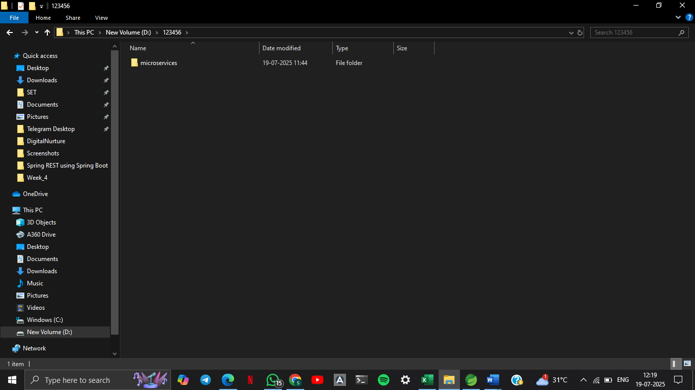

Generate Project from Spring Initializr :

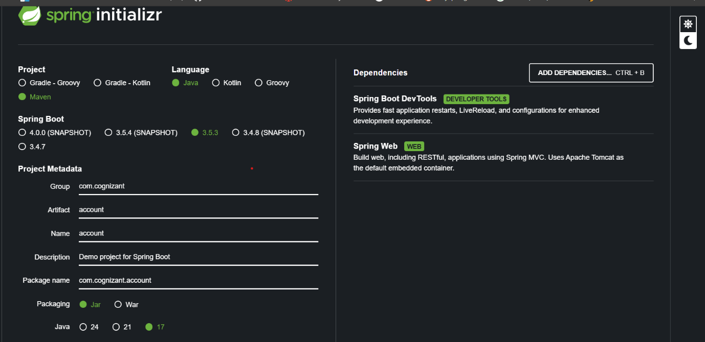

**AccountController.java :**

package com.cognizant.account.controller;

import org.springframework.web.bind.annotation.*;

import java.util.Map;

*@RestController*

*@RequestMapping*("/accounts")

public class AccountController {

*@GetMapping*("/{number}")

public Map<String, Object> getAccount(*@PathVariable* String number) {

return Map.*of*(

"number", number,

"type", "savings",

"balance", 234343

);

}

}

**AccountApplication.java :**

package com.cognizant.account;

import org.springframework.boot.SpringApplication;

import org.springframework.boot.autoconfigure.SpringBootApplication;

*@SpringBootApplication*

public class AccountApplication {

public static void main(String[] args) {

SpringApplication.*run*(AccountApplication.class, args);

}

}

**Application.properties :**

spring.application.name=account

**OUTPUT :**

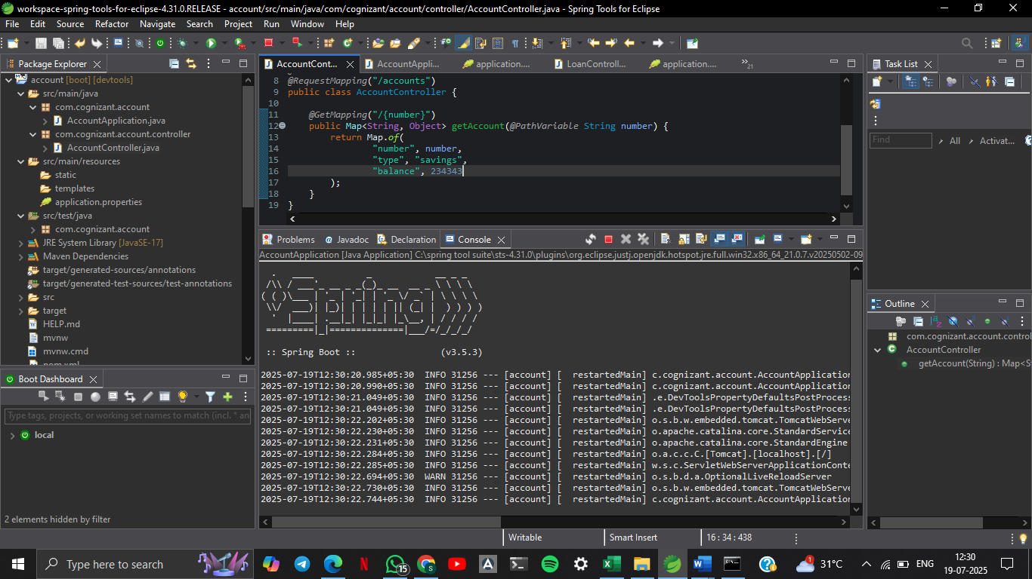

**http://localhost:8080/accounts/00987987973432**

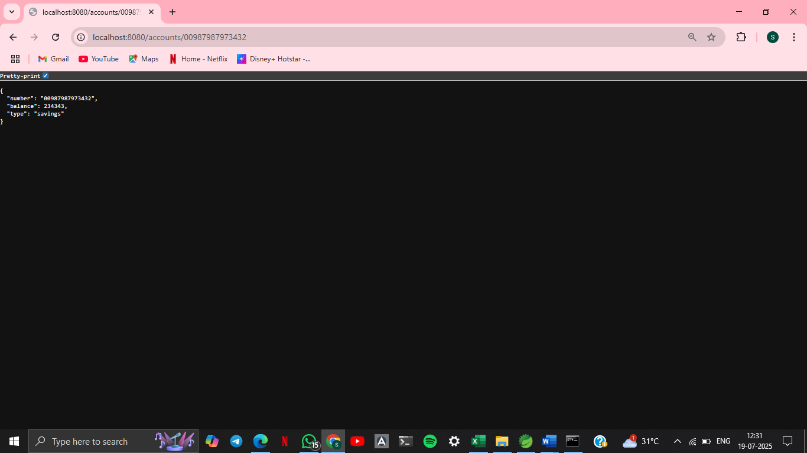

**Loan Microservice Setup :**

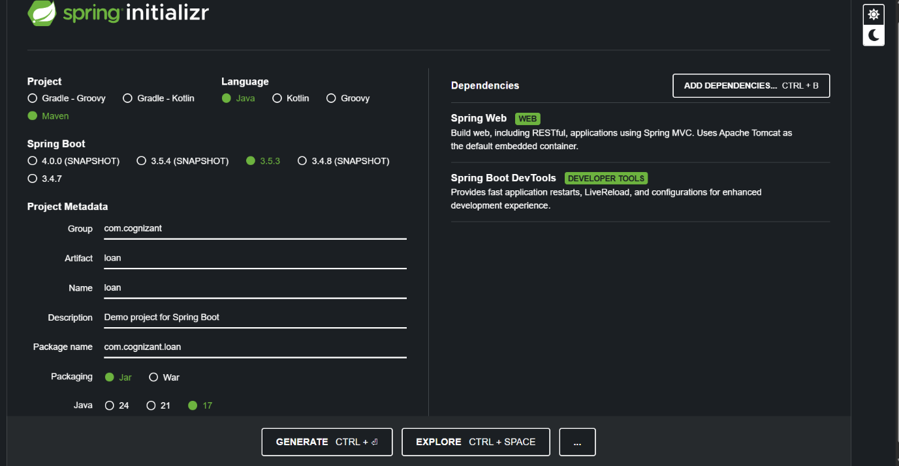

**LoanController.java :**

package com.cognizant.loan.controller;

import org.springframework.web.bind.annotation.*;

import java.util.Map;

*@RestController*

*@RequestMapping*("/loans")

public class LoanController {

*@GetMapping*("/{number}")

public Map<String, Object> getLoan(*@PathVariable* String number) {

return Map.*of*(

"number", number,

"type", "car",

"loan", 400000,

"emi", 3258,

"tenure", 18

);

}

}

**OUTPUT :**

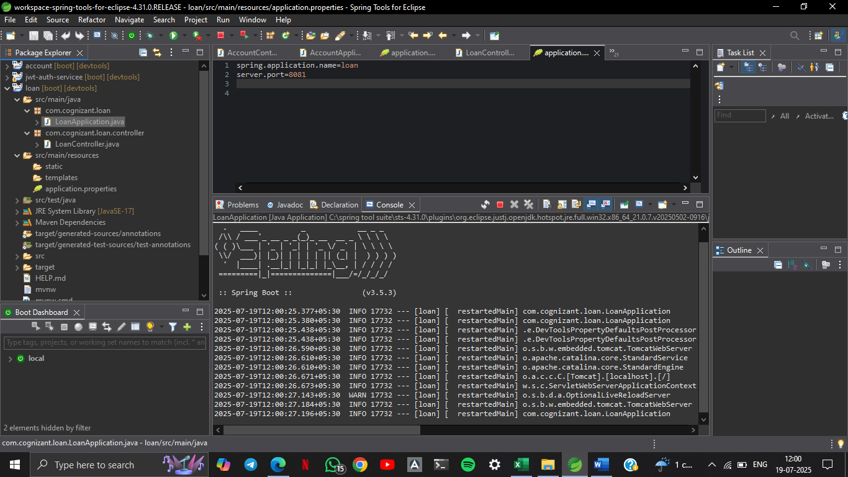

**http://localhost:8081/loans/H00987987972342**

